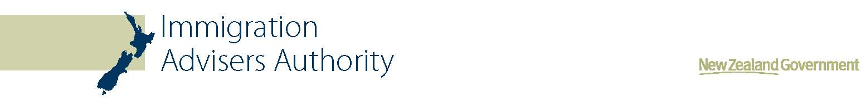
Media release
17 April 2015

Unlicensed immigration adviser receives further jail term
Unlicensed immigration adviser Richard Martin has today been sentenced to an additional two and a half months’ imprisonment on two charges relating to providing immigration advice without a licence.

The 50 year old former immigration lawyer was sentenced in the North Shore District Court this morning on two charges of providing immigration advice without being licensed or exempt, knowing that he was required to be.

Registrar of Immigration Advisers Catherine Albiston says, “The Immigration Advisers Authority (IAA) was set up to protect those seeking New Zealand immigration advice. The public can have confidence that the IAA takes unlicensed activity very seriously and will prosecute unlicensed advisers found to be operating outside the law, as is the case today. “

Richard Martin is currently serving a three year seven month term of imprisonment on 93 immigration-related charges which he was found guilty of in June 2014. This was the heaviest penalty handed down to an unlicensed adviser, since the Immigration Advisers Authority was established in 2007. The offending which he was sentenced for today was committed while Martin was on bail for these other offences.

The offending was committed between September 2012 and May 2013 when Martin provided immigration advice through Richard Martin Immigration Limited to three separate people.

In one of the cases, Martin received a total of $4,600 from an Indian client who was not aware Martin was unlicensed and had contracted him to assist with an application for residence.

In May 2013, Immigration New Zealand contacted the client advising they needed additional information for his residency application. The client then attempted to contact Martin several times for further assistance, but could not reach him, so he approached a Licensed Immigration Adviser for assistance and it was then that he was told Martin was not licensed to provide immigration advice.

In the other case, a client sought Martin’s assistance in September 2012, seeking information about getting visas for his partner and her son, who were coming to New Zealand from Belgium.

Upon their arrival, visa applications were made to Immigration New Zealand (INZ) who then raised questions about Martin’s involvement in their application, given he was neither licensed nor exempt.

Martin told the clients that he employed licensed advisers to lodge cases, however the clients had never met with or spoken to anyone else employed by Richard Martin Immigration Ltd, except for Martin himself. He also told the clients to tell INZ that no adviser was used for their visa applications, if they were specifically asked.

Catherine Albiston says, “We encourage anyone seeking New Zealand immigration advice to use a licensed immigration adviser, or an exempt person. Licensed immigration advisers are immigration specialists; they must meet competency standards and follow a code of conduct. All licensed advisers can be found on a publicly available register on our website.”

ENDS
Notes to editor
The Immigration Advisers Authority was set up to protect people receiving New Zealand immigration advice.
It does this by:
- issuing licences to people who are fit and competent to give immigration advice
- maintaining competency standards and a code of conduct for immigration advisers
- receiving complaints against licensed immigration advisers
- investigating people giving immigration advice without a licence or exemption.

Under the Immigration Advisers Licensing Act 2007 anyone giving immigration advice must have a licence unless they are exempt. Exempt people include lawyers with a current New Zealand practising certificate and Citizens Advice Bureau staff among others.
The Authority is independent of Immigration New Zealand and cannot give immigration advice or influence a visa application.

